Outline Specification  
Galvanic Anodes for Patch Repairs

**1. Description**

Galvanic anodes for controlling corrosion adjacent to concrete patch repairs (BS EN1504 – Part 9 Principle 10). Anodes to be installed into drilled holes around the internal perimeter of broken out patches such that the anodes are located within the host concrete.

**2. Materials**

**2.1 General**

2.1.1 The contractor shall maintain a record of all materials installed and locations. A record of specified testing shall be maintained by the contractor.

2.1.2 The galvanic anode unit shall have been used on a minimum of five projects, similar to the current project, and be supplied by a manufacturing company certified to ISO 9001. The anode materials shall have been evaluated by an independent party with published test data.

2.1.3 The anodes shall be installed by a contractor approved by the Engineer and materials supplier.

**2.2 Anode**

2.2.1 Anode size shall be determined by steel density and the local environment, with reference to the manufacturer’s guidelines. Anode units shall be pre- manufactured and contain a cylindrical zinc alloy core coated with an activator and shall conform to the following criteria:

|  |  |  |  |
| --- | --- | --- | --- |
| **Diameter** | **Length** | **Zinc Weight** | **Min. Charge Capacity** |
| 18mm (3/4”) | 42mm (1 5/8”) | 65g | 150kC |
| 18mm (3/4”) | 77mm (3”) | 120g | 300kC |
| 18mm (3/4”) | 95mm (3 ¾”) | 160g | 400kC |
| 18mm (3/4”) | 115mm (4 1/2”) | 180g | 450kC |

2.2.2 Anodes and anode systems shall be manufactured with an expected design life of 10-20 years subject to local environment.

2.2.3 The anode assembly shall incorporate an inert plastic spacer around the anode with flexible components so that the anode is located centrally and securely within the drilled hole, allowing for complete encapsulation with the manufacturer supplied embedment mortar.

2.2.4 Anode units shall be supplied with integral un-spliced conductor wire of length at least 240mm (91⁄2”) for directly tying to the reinforcing steel and other embedded metals. The conductor shall be formed of 1.2mm diameter SAE 304 stainless steel.

2.2.5 Anodes shall be supplied with inert, non-metallic ties for attaching and securing the anode stainless steel wires to the reinforcing steel.

2.2.6 Embedment material for anodes shall be a pre-mixed, single component specially formulated mortar provided by the manufacturer in sealed 310ml (10.5oz) tubes which remains pliable when installed for greater than 48 hours. The mortar shall have sufficient ionic conductivity to enhance current delivery from the anode unit for the intended design service-life. The dispensing equipment shall have a nozzle of sufficient length to allow the application of mortar to the base of the hole and eliminate air voids.

**2.3 Products**

2.3.1 The following products shall be acceptable for this project. CPT PatchGuard anodes with DuoCrete PG mortar from:

No Corrosion, LLC (NoCo)

1230 52nd St, Ste B  
West Palm Beach, FL 33407

email: info@noco.tech

phone: 561-570-2994

web: www.noco.tech

2.3.2 Deliver, store and handle all materials in accordance with manufacturer’s instructions. Store all materials in sealed containers with manufacturer’s supplied desiccants. Adhere to manufacturer’s safety requirements. Discard any material that is not used within the manufacturer’s permitted timeframe or has been stored outside the manufacturer’s required environmental conditions. Only use newly opened tubes of embedment material for anode embedment. Do not install or store materials outside the recommended temperature range.

**3. Installation of Anodes**

**3.1 Preliminaries**

3.1.1 Reinforcement Continuity

Confirm electrical continuity between all exposed steel within the repair area by measuring the electrical resistance between reinforcing bars following the method and acceptance criteria as specified in EN ISO 12696:2016, clause 7.1.

Any electrically discontinuous steel shall be made continuous.

3.1.2 Reinforcement detail – steel reinforcement in the areas to be protected shall be identified to confirm detail in the original drawings and that the design is appropriate.

**3.2 Installation**

3.2.1 Holes shall be drilled into the parent concrete at the internal perimeter edge of the broken-out patches at locations identified by the engineer. The spacing between anodes shall be determined by steel density and the local environment, with reference to the manufacturer’s guidelines. Spacing between anodes shall in no case exceed 650mm (25”) around the periphery of the patch repair. A hole of 25mm (1”) diameter, 5mm (1⁄4”) deeper than the anode length, shall be drilled to accommodate each anode unit.

Note that the anodes shall be installed at the edges of repairs. This is particularly important on beam/column repairs as the extreme edges of any beam/column repairs are most susceptible to further corrosion activity.

3.2.2 Clean the steel surface in the vicinity of the anode unit location, removing any oxide layer, to facilitate electrical connection of the anode.

3.2.3 Remove all dust and debris from the drilled hole and pre-wet the hole with water for a minimum of 15 minutes. Once the excess water has been removed from the bottom of the hole, the embedment mortar shall be applied into the hole with a nozzle to ensure no entrapment of air voids within the mortar matrix.

Note: Ensure any water which has settled on the surface of the mortar within the cartridge is poured into a suitable container prior to expressing the paste.

3.2.4 The anode shall be placed into the hole and inserted such that the embedment mortar encapsulates the whole unit. No additional bridging mortars shall be used.

3.2.5 The protruding conductor wire from the anode shall be directly connected to the cleaned reinforcing steel by winding at least twice around the rebar and fixing the tail twice with the supplied plastic ties.

Electrical continuity between the stainless steel anode conductor wire and the reinforcement bar shall be confirmed by use of a voltmeter. Electrical continuity shall be confirmed if a resistance reading of less than 0.5 ohm is obtained.

If the measured resistance is >0.5 ohm then the anode tying point shall be removed, the reinforcing steel cleaned and the anode connection to the steel reinstated until a resistance of less than 0.5 ohm is achieved.

3.2.6 All patch repairs incorporating the anodes shall be reinstated immediately following the completion of the installation or, if reinstatement is to be delayed by more than 1 hour, the anode/embedment mortar shall be capped with a layer of repair mortar to prevent contamination and drying. Capping mortar shall be the same as, or compatible with, the specified patch repair mortar.

3.2.7 Patch repair material cover to the anode units must be a minimum of 20mm (7⁄8”).

3.2.8 Within 24 hours of anode installation, a copper sulphate reference electrode and multimeter shall be used to measure potential above and immediately adjacent to each anode. The potential above the anodes should be more negative than areas immediately adjacent.

**4.0 Typical Installation Detail**

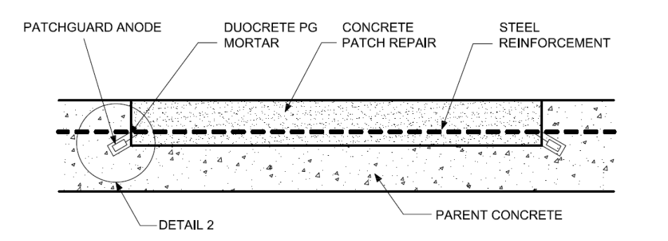

Note -This sample specification should be modified as appropriate to reflect project specific conditions before being incorporated into contract documents. Users shall satisfy themselves that the specification details apply to their particular works and that there is compliance with all relevant regulations and standards.